Problem 1: Stationery Shop Receipts (Units 1 & 2)

CODE | import java.util.Scanner;  class Product {  private final String name;  private final int price;  public Product(String name, int price) {  this.name = name;  this.price = price;  }  public String getName() {  return name;  }  public int getPrice() {  return price;  }  public static Product findProduct(char code) {  return switch (code) {  case 'N' -> new Product("Notebook", 45);  case 'P' -> new Product("Pen", 10);  case 'M' -> new Product("Marker", 25);  case 'F' -> new Product("File", 30);  default -> null;  };  }  }  class Purchase {  private int receiptNo;  private Product product;  private int quantity;  private static int nextReceipt = 201;  private static int totalPurchases = 0;  private static int totalRevenue = 0;  public Purchase(Product product, int quantity) {  this.product = product;  this.quantity = quantity;  this.receiptNo = nextReceipt++;  totalPurchases++;  totalRevenue += getAmount();  }  public int getAmount() {  return product.getPrice() * quantity;  }  public static int getTotalPurchases() {  return totalPurchases;  }  public static int getTotalRevenue() {  return totalRevenue;  }  @Override  public String toString() {  return "Receipt " + receiptNo + ": " + product.getName() + " x " + quantity + " = " + getAmount();  }  }  public class Main {  public static void main(String[] args) {  Scanner sc = new Scanner(System.in);  int n = sc.nextInt();  for (int i = 0; i < n; i++) {  char code = sc.next().charAt(0);  int quantity = sc.nextInt();  Product product = Product.findProduct(code);  if (product == null || quantity <= 0) {  System.out.println("Invalid item: " + code + " " + quantity);  } else {  Purchase purchase = new Purchase(product, quantity);  System.out.println(purchase);  }  }  System.out.println("Total receipts: "  + Purchase.getTotalPurchases()  + ", Total revenue: "  + Purchase.getTotalRevenue());  sc.close();  }  }
O/P | 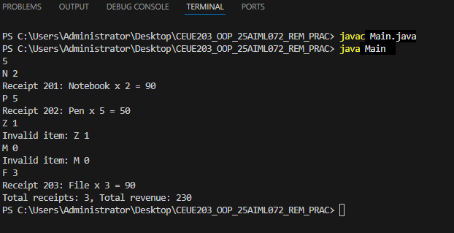

Problem 2: Notice Cleaner (Unit 3)

CODE | import java.util.Scanner;  public class String3 {  public static void main(String[] args) {  Scanner sc = new Scanner(System.in);  String sentence = sc.nextLine();  String keyword = sc.nextLine();  String trimmed = sentence.trim();  String[] words = trimmed.split(" +");  StringBuilder cleaned = new StringBuilder();  for (int i = 0; i < words.length; i++) {  if (i > 0) {  cleaned.append(" ");  }  cleaned.append(words[i].toLowerCase());  }  cleaned.setCharAt(  0,  Character.toUpperCase(cleaned.charAt(0))  );  String shortestWord = words[0].toLowerCase();  int keywordCount = 0;  int vowelCount = 0;  for (String word : words) {  String lowerWord = word.toLowerCase();  if (lowerWord.length() < shortestWord.length()) {  shortestWord = lowerWord;  }  if (lowerWord.equals(keyword.toLowerCase())) {  keywordCount++;  }  }  for (int i = 0; i < sentence.length(); i++) {  char ch = Character.toLowerCase(sentence.charAt(i));  if (ch == 'a' || ch == 'e' || ch == 'i'|| ch == 'o' || ch == 'u')  {  vowelCount++;  }  }  System.out.println("Sentence: " + cleaned);  System.out.println("Words: " + words.length);  System.out.println("Shortest word: " + shortestWord);  System.out.println("Keyword count: " + keywordCount);  System.out.println("Vowels: " + vowelCount);  sc.close();  }  }
O/P | 